**HOW TO CHECK AVALAIBLE CONDA ENVS**

*conda info –envs*

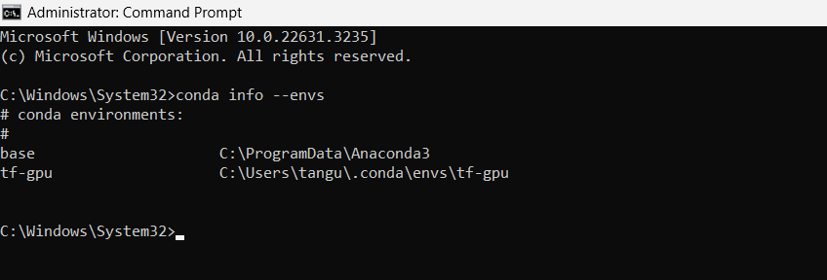

**HOW TO CREATE A NEW ENV WITH PYTHON3**

*conda create --name py3-TF2 python=3*

Note: it is always recommended to include the name of the programming language in the name of the environment.

When i got to this stage on my windows 10, i encountered the following error

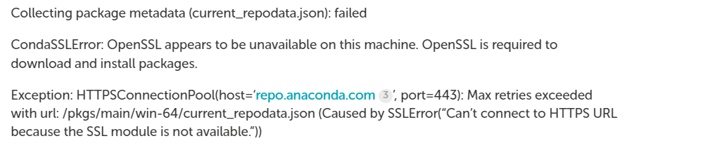

And resolved it through the following guide

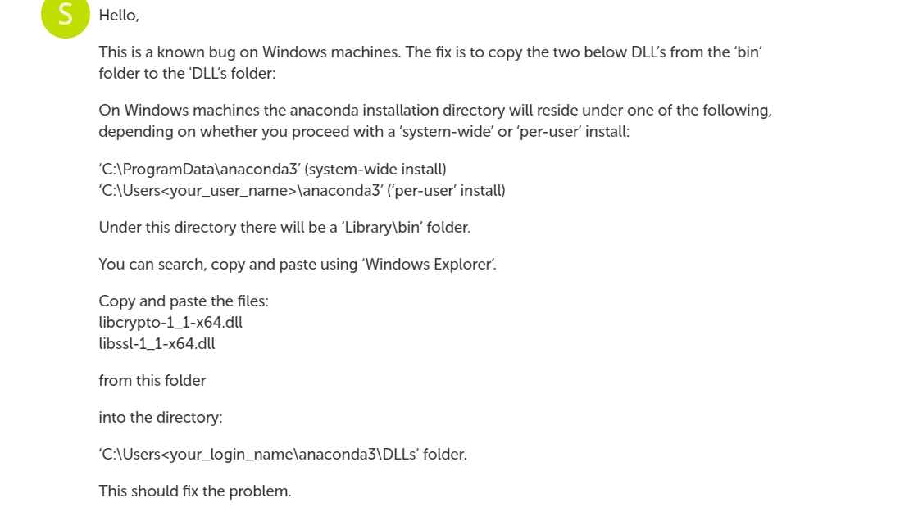

The solution was gotten from the site: <https://community.anaconda.cloud/t/getting-openssl-working/51512/3>

And after applying it, i tried again and everything went on smoothly

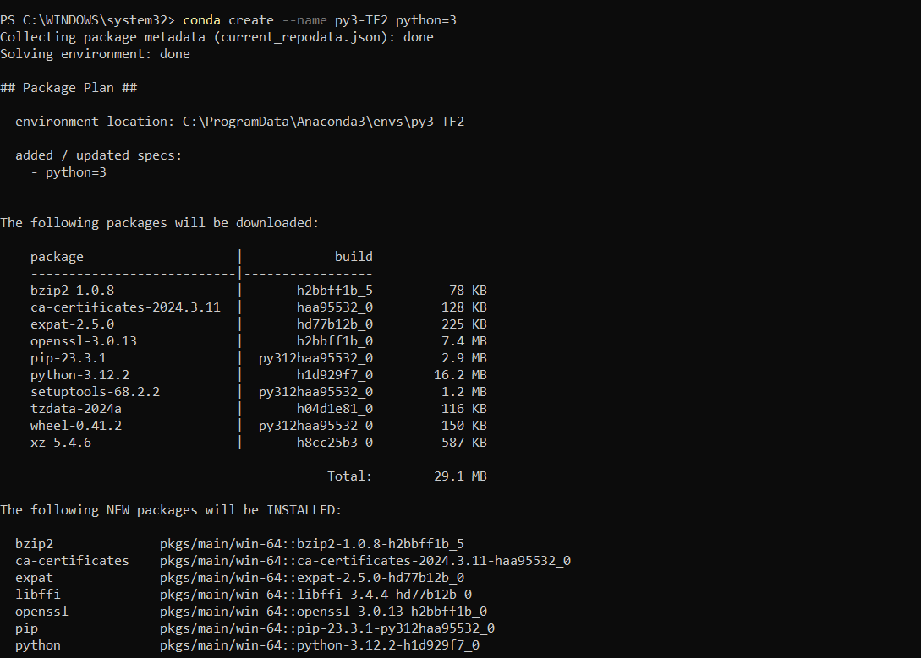

**ACTIVATING THE ENVIRONMENT**

*conda activate py3-TF2*

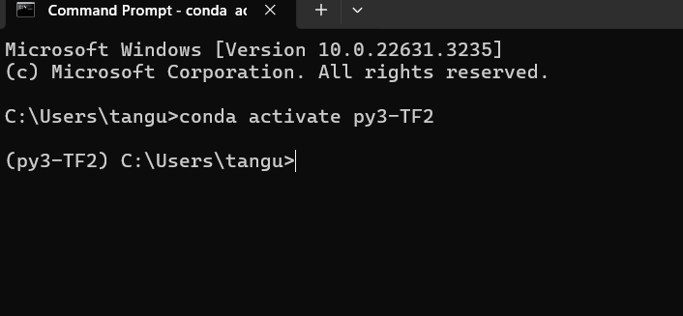

**LETS INSTALL TENSORFLOW**

while in the new env type the following

*conda install tensorflow*

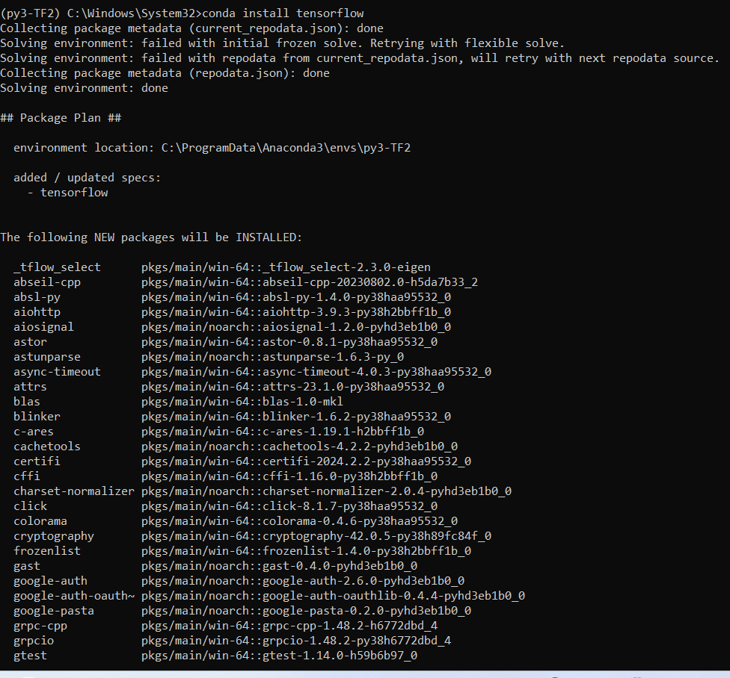

**UPGRADING TENSORFLOW**

*pip install --upgrade tensorflow*

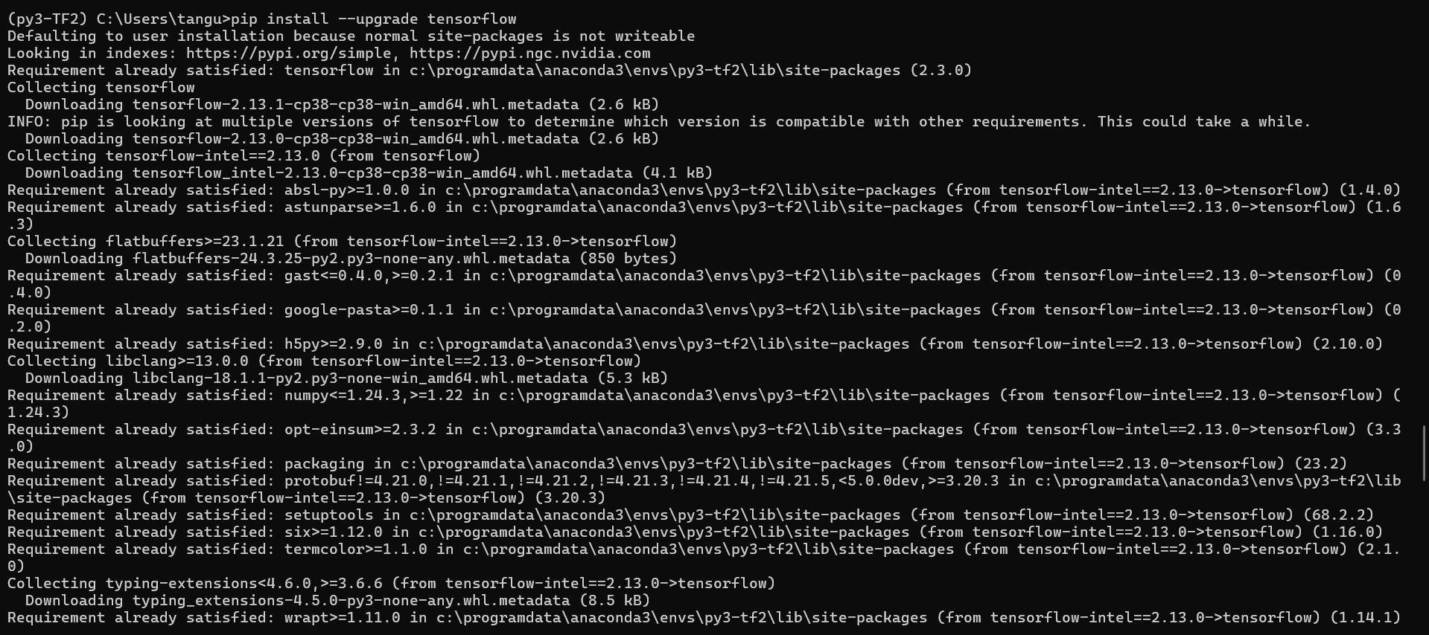

**HOW TO ADD YOUR ENV AS A KERNEL ON JUPYTER**

*pip install ipykernel*

followed by

*python -m ipykernel install --user --name=nameOfEnv*

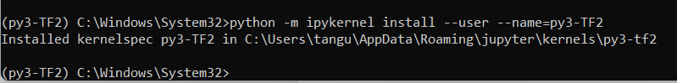

Please restart anaconda and jupyter to verify if everything is working

*in a jupyter cell try*

*import tensorflow as tf*

*print(tf.__version___)*

when executing mine, i encountered the following error

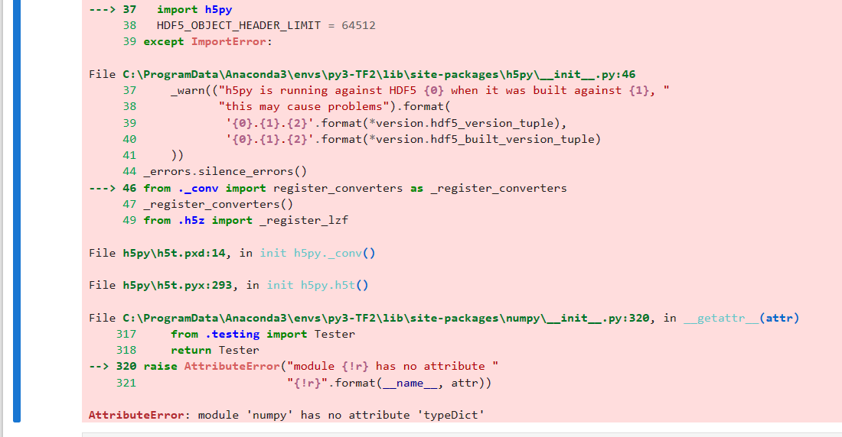

Fixed it with the following command, which downgrades my numpy from v 1.24.2 to v 1.22

pip install numpy==1.22